**AI (data, graphs )**

**WORLD STRUCTURE**

**JOB MARKET**

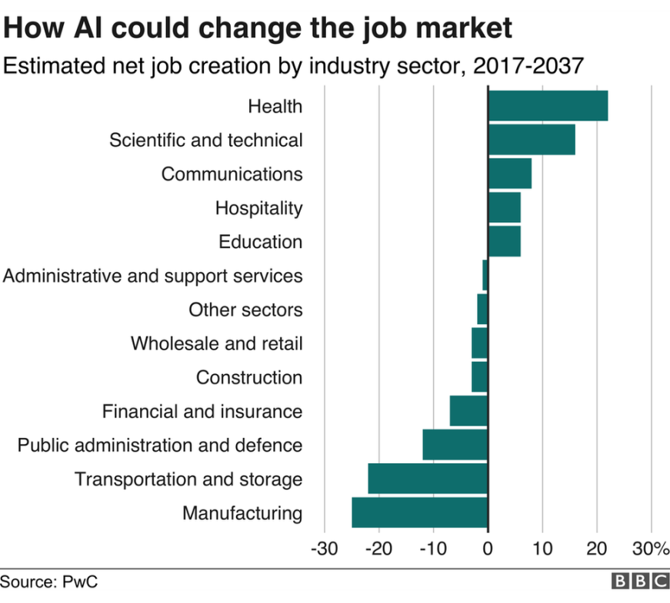

**AI IN COMPANIES AND SECTORS**

AI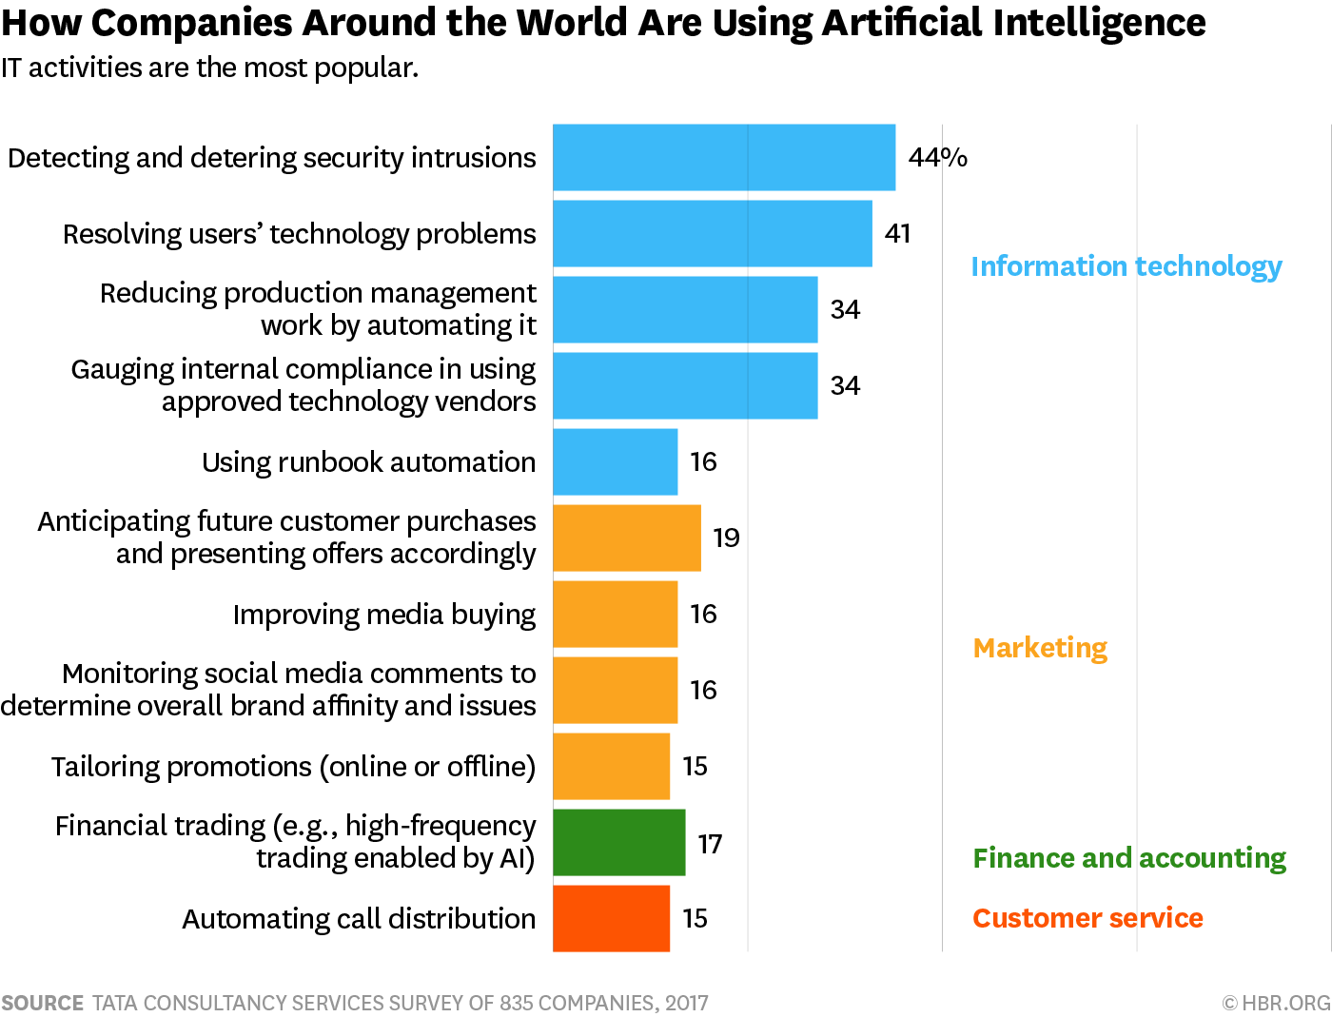

**GROWTH RATE IN INDIA**

Artificial Intelligence has got a bright and promising future in India. AI has the possibility to add $957 billion or 15% of the present gross value – to the Indian economy by 2035. “Start-ups witnessed a 108% growth in financial India in 2018.” The report also stated that Artificial Intelligence was among the domains that witnessed the fastest adoption among different industry sectors. Presently there are 400 startups working on AI and machine learning domains. About $150 million is invested in India’s AI industry by private players and the number has been increasing since 2016.

**RISK & FEAR IN INDIA**

IN INDIA, the AI market is in growing stage( many of them are startups not giants).

Aakrit Vaish from Haptik, Inc. shares his thoughts on the AI hype that he sees in the Indian tech scene today:

*“Today AI is getting a lot of attention in India but nobody knows what it is or what are the best applications for it. There’s a little of a spray-and-pray attitude across the board.”*

AI may automate low-end services work, call center work, and BPO work:

* The fear that AI is stealing jobs is not unique to India, but it could hit this country particularly hard because a big of its economy comes from IT services which involve relatively routine work that is prime for computers to take over.
* Looking ahead five years in the future, in some cases, Indian IT services companies will automate the work themselves (requiring upskilling of the workforce). In other cases, companies in the West will do it, so they no longer have to outsource work out to humans in India (resulting in loss of business).
* We believe that if the Indian tech services sector doesn’t embrace AI, or if they only embrace low-end data entry and data labeling work, automation and encroachment from foreign tech firms could be a significant financial blow to the country.

**PEOPLES OPINION ON ARITIFICIAL INTELLIGENCE**

